1. **Array Operations**

**#include<stdio.h>**

**int main()**

**{**

**int arr[10],i,num;**

**int found=0;**

**printf("Enter array elements\n");**

**for(i=0;i<10;i++)**

**{**

**scanf("%d",&num);**

**}**

**printf("Enter the no. of choice");**

**scanf("%d",&num);**

**for(i=0;i<10;i++)**

**{**

**if(num==arr[i])**

**{**

**printf("The no %d is present in the array",num);**

**found=found+1;**

**break;**

**}**

**}**

**if(found==0)**

**{**

**printf("the no. is not found");**

**}**

**return 0;**

**}**

**Output :**

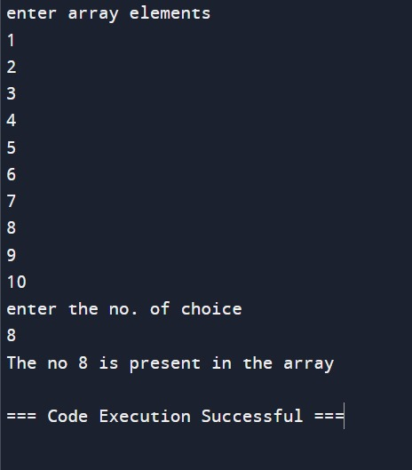

1. **Code to update some element of array**

#include<stdio.h>

int main()

{

    int i,t,a[10],n,m,s,j=0,b[10];

    printf("\nEnter the limit:");

    scanf("%d",&n);

    printf("\nEnter the values:");

    for(i=0;i<n;i++)

    {

        scanf("%d",&a[i]);

    }

    printf("\nGiven values are:");

    for(i=0;i<n;i++)

    {

        printf("a[%d]=%d",i,a[i]);

    }

    printf("\nEnter the position to be updated:");

    scanf("%d",&t);

    printf("\nEnter the value to be update:");

    scanf("%d",&s);

    for(i=0;i<n;i++)

    {

        if(i==t)

        {

a[i]=s;

        }

    }

    printf("\n Updated values is:");

    for(i=0;i<n;i++)

    {

        printf("\na[%d]=%d",i,a[i]);

    }

    return 0;

}

Output:

